25K-6551
LAB 07 TASKS :

CODE 1 :
#include <stdio.h>

int main() {
int arr[5];
int i, temp;

printf("Enter 5 integers:\n");
for(i = 0; i < 5; i++){
scanf("%d", &arr[i]);
}

temp = arr[4];
for(i = 4; i > 0; i--){
arr[i] = arr[i-1]; }

arr[0] = temp;
printf("Output: ");
for(i = 0; i < 5; i++){
printf("%d ", arr[i]);
}

return 0;
}
OUTPUT :
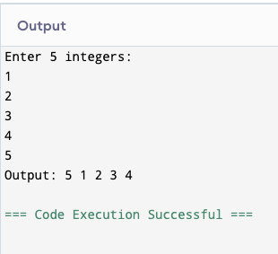
TASK 2 :
CODE 2 :
#include <stdio.h>

int main() {
int arr[10];
int i, num, count = 0;

printf("Enter 10 numbers:\n");
for(i = 0; i < 10; i++){
scanf("%d", &arr[i]);
}

printf("Enter number to search: ");
scanf("%d", &num);

for(i = 0; i < 10; i++){
if(arr[i] == num){
count++;
}
}

if(count == 0){
printf("Number not found");
}
else{
printf("Number occurred %d times", count);
}

return 0;
}
OUTPUT :
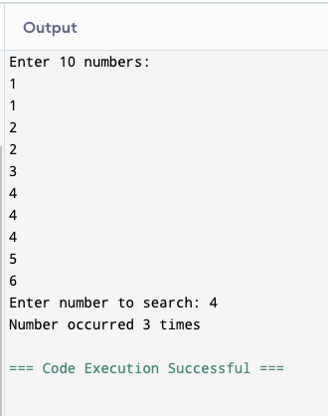
TASK 3 :
CODE 3 :
#include <stdio.h>

int main() {
int pass[10], fail[10];
int mark;
int i;
int p = 0, f = 0;
float avgPass = 0, avgFail = 0;

for(i = 0; i < 10; i++){
printf("Enter quiz marks (-1 to exit): ");
scanf("%d", &mark);

if(mark == -1)
break;

if(mark >= 5 && mark <= 10){
pass[p] = mark;
avgPass += mark;
p++;
}
else if(mark >= 0 && mark < 5){
fail[f] = mark;
avgFail += mark;
f++;
}
else{
printf("Invalid marks\n");
}
}

printf("\nPass Students Marks: ");
for(i = 0; i < p; i++){
printf("%d ", pass[i]);
}

if(p > 0)
printf("\nAverage Pass Marks = %.2f", avgPass / p);
else
printf("\nNo pass students");

printf("\n\nFail Students Marks: ");
for(i = 0; i < f; i++){
printf("%d ", fail[i]);
}

if(f > 0)
printf("\nAverage Fail Marks = %.2f", avgFail / f);
else
printf("\nNo fail students");

return 0;
}
OUTPUT :
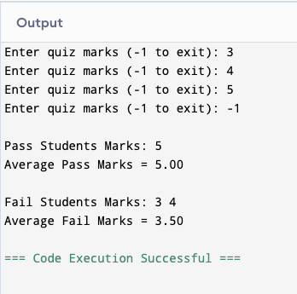
TASK 4 :

CODE 4 :
#include <stdio.h>

int main() {
char str[100];
int i = 0;

printf("Enter a sentence: ");
scanf("%[^\n]", str);

while(str[i] != '\0'){
if(str[i] >= 'A' && str[i] <= 'Z'){
str[i] = str[i] + 32;
}
else if(str[i] >= 'a' && str[i] <= 'z'){
str[i] = str[i] - 32;
}
i++;
}

printf("Converted message: %s", str);

return 0;
}

OUTPUT :
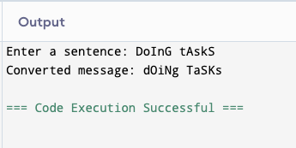
TASK 5 :

CODE 5 :
#include <stdio.h>

int main() {
int arr[10];
int i, max, min, diff;

printf("Enter 10 integers:\n");
for(i = 0; i < 10; i++){
scanf("%d", &arr[i]);
}

max = arr[0];
min = arr[0];

for(i = 1; i < 10; i++){
if(arr[i] > max)
max = arr[i];

if(arr[i] < min)
min = arr[i];
}

diff = max - min;

printf("Max = %d\n", max);
printf("Min = %d\n", min);
printf("Difference = %d\n", diff);

return 0;
}

OUTPUT :
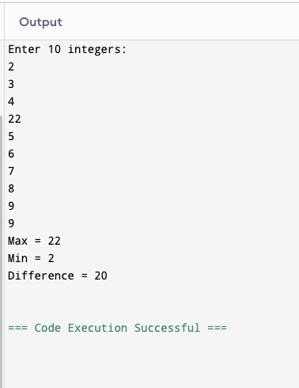
TASK 6 :

CODE 6 :

#include <stdio.h>

int main() {
char str[100];
int i = 0;
int vowels = 0, consonants = 0;

printf("Enter a word: ");
scanf("%s", str);

while(str[i] != '\0'){
if(str[i]=='a' || str[i]=='e' || str[i]=='i' || str[i]=='o' || str[i]=='u' ||
str[i]=='A' || str[i]=='E' || str[i]=='I' || str[i]=='O' || str[i]=='U'){
vowels++;
}
else{
consonants++;
}
i++;
}

printf("Vowels = %d\n", vowels);
printf("Consonants = %d\n", consonants);

return 0;
}
OUTPUT :

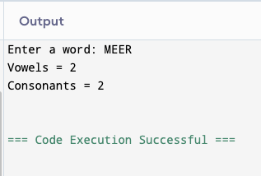
TASK 7 :

CODE 7 :
#include <stdio.h>

int main() {
int arr[10];
int i, j;

printf("Enter 10 integers:\n");
for(i = 0; i < 10; i++){
scanf("%d", &arr[i]);
}

for(i = 0; i < 10; i++){
for(j = 0; j < i; j++){
if(arr[i] == arr[j]){
arr[i] = -1;
break; // no need to check further
}
}
}

printf("Updated array:\n");
for(i = 0; i < 10; i++){
printf("%d ", arr[i]);
}

return 0;
}

OUTPUT :
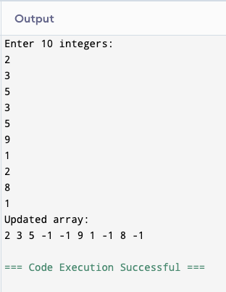
TASK 8 :

CODE 8 :

#include <stdio.h>

int main() {
char input[100], nonAlpha[100];
int i = 0, j = 0;

printf("Enter a string: ");
scanf(" %[^\n]", input); // read full line including spaces

while(input[i] != '\0') {
// check if character is NOT a letter
if(!((input[i] >= 'A' && input[i] <= 'Z') || (input[i] >= 'a' && input[i] <= 'z'))) {
nonAlpha[j] = input[i];
j++;
}
i++;
}

nonAlpha[j] = '\0'; // terminate string

printf("Non-alphabetic characters: %s\n", nonAlpha);

return 0;
}
OUTPUT :
